
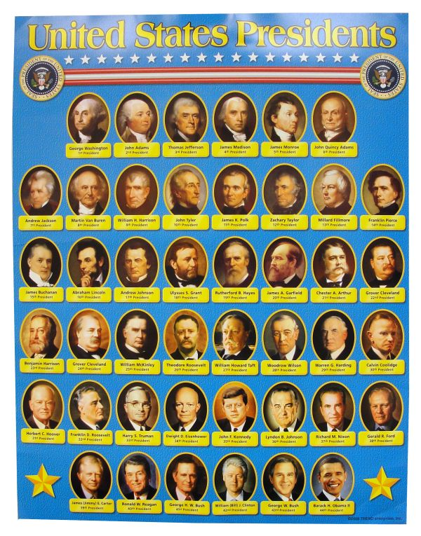

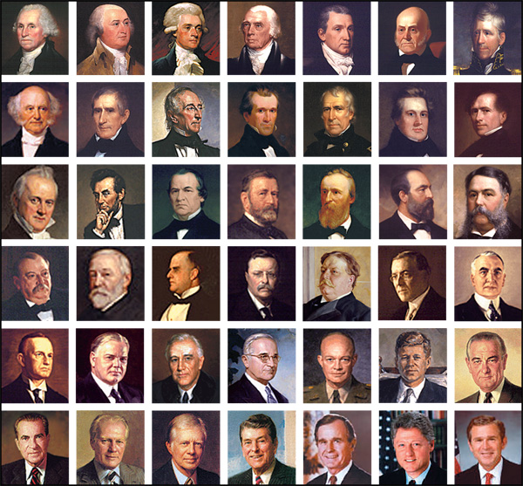
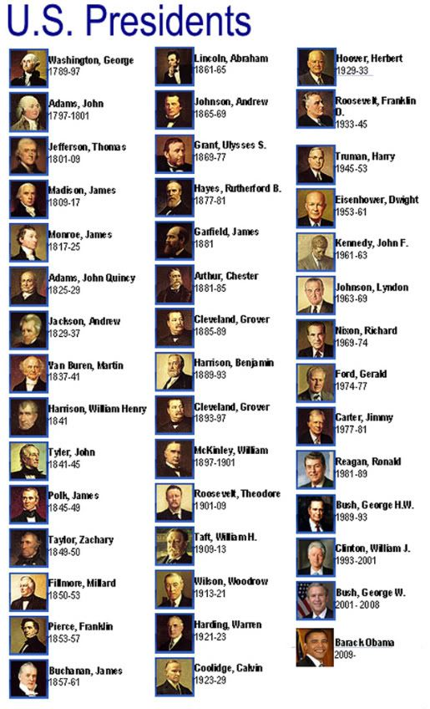
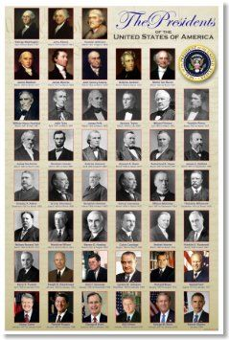

INCLUDEPICTURE "http://t0.gstatic.com/images?q=tbn:ANd9GcTDT1jpfS6n_Y4NmsXFnf0dV2uAk854tEHeOSaIXPxUCt7qxHu5xaSaZA" \* MERGEFORMATINET INCLUDEPICTURE "http://t0.gstatic.com/images?q=tbn:ANd9GcTDT1jpfS6n_Y4NmsXFnf0dV2uAk854tEHeOSaIXPxUCt7qxHu5xaSaZA" \* MERGEFORMATINET INCLUDEPICTURE "http://t0.gstatic.com/images?q=tbn:ANd9GcTDT1jpfS6n_Y4NmsXFnf0dV2uAk854tEHeOSaIXPxUCt7qxHu5xaSaZA" \* MERGEFORMATINET INCLUDEPICTURE "http://t0.gstatic.com/images?q=tbn:ANd9GcTDT1jpfS6n_Y4NmsXFnf0dV2uAk854tEHeOSaIXPxUCt7qxHu5xaSaZA" \* MERGEFORMATINET INCLUDEPICTURE "http://t0.gstatic.com/images?q=tbn:ANd9GcTDT1jpfS6n_Y4NmsXFnf0dV2uAk854tEHeOSaIXPxUCt7qxHu5xaSaZA" \* MERGEFORMATINET INCLUDEPICTURE "http://t0.gstatic.com/images?q=tbn:ANd9GcTDT1jpfS6n_Y4NmsXFnf0dV2uAk854tEHeOSaIXPxUCt7qxHu5xaSaZA" \* MERGEFORMATINET INCLUDEPICTURE "http://t0.gstatic.com/images?q=tbn:ANd9GcTDT1jpfS6n_Y4NmsXFnf0dV2uAk854tEHeOSaIXPxUCt7qxHu5xaSaZA" \* MERGEFORMATINET INCLUDEPICTURE "http://t0.gstatic.com/images?q=tbn:ANd9GcTDT1jpfS6n_Y4NmsXFnf0dV2uAk854tEHeOSaIXPxUCt7qxHu5xaSaZA" \* MERGEFORMATINET INCLUDEPICTURE "http://t0.gstatic.com/images?q=tbn:ANd9GcTDT1jpfS6n_Y4NmsXFnf0dV2uAk854tEHeOSaIXPxUCt7qxHu5xaSaZA" \* MERGEFORMATINET INCLUDEPICTURE "http://t0.gstatic.com/images?q=tbn:ANd9GcTDT1jpfS6n_Y4NmsXFnf0dV2uAk854tEHeOSaIXPxUCt7qxHu5xaSaZA" \* MERGEFORMATINET INCLUDEPICTURE "http://t0.gstatic.com/images?q=tbn:ANd9GcTDT1jpfS6n_Y4NmsXFnf0dV2uAk854tEHeOSaIXPxUCt7qxHu5xaSaZA" \* MERGEFORMATINET INCLUDEPICTURE "http://t0.gstatic.com/images?q=tbn:ANd9GcTDT1jpfS6n_Y4NmsXFnf0dV2uAk854tEHeOSaIXPxUCt7qxHu5xaSaZA" \* MERGEFORMATINET INCLUDEPICTURE "http://t0.gstatic.com/images?q=tbn:ANd9GcTDT1jpfS6n_Y4NmsXFnf0dV2uAk854tEHeOSaIXPxUCt7qxHu5xaSaZA" \* MERGEFORMATINET INCLUDEPICTURE "http://t0.gstatic.com/images?q=tbn:ANd9GcTDT1jpfS6n_Y4NmsXFnf0dV2uAk854tEHeOSaIXPxUCt7qxHu5xaSaZA" \* MERGEFORMATINET INCLUDEPICTURE "http://t0.gstatic.com/images?q=tbn:ANd9GcTDT1jpfS6n_Y4NmsXFnf0dV2uAk854tEHeOSaIXPxUCt7qxHu5xaSaZA" \* MERGEFORMATINET INCLUDEPICTURE "http://t0.gstatic.com/images?q=tbn:ANd9GcTDT1jpfS6n_Y4NmsXFnf0dV2uAk854tEHeOSaIXPxUCt7qxHu5xaSaZA" \* MERGEFORMATINET INCLUDEPICTURE "http://t0.gstatic.com/images?q=tbn:ANd9GcTDT1jpfS6n_Y4NmsXFnf0dV2uAk854tEHeOSaIXPxUCt7qxHu5xaSaZA" \* MERGEFORMATINET INCLUDEPICTURE "http://t0.gstatic.com/images?q=tbn:ANd9GcTDT1jpfS6n_Y4NmsXFnf0dV2uAk854tEHeOSaIXPxUCt7qxHu5xaSaZA" \* MERGEFORMATINET INCLUDEPICTURE "http://t0.gstatic.com/images?q=tbn:ANd9GcTDT1jpfS6n_Y4NmsXFnf0dV2uAk854tEHeOSaIXPxUCt7qxHu5xaSaZA" \* MERGEFORMATINET INCLUDEPICTURE "http://t0.gstatic.com/images?q=tbn:ANd9GcTDT1jpfS6n_Y4NmsXFnf0dV2uAk854tEHeOSaIXPxUCt7qxHu5xaSaZA" \* MERGEFORMATINET INCLUDEPICTURE "http://t0.gstatic.com/images?q=tbn:ANd9GcTDT1jpfS6n_Y4NmsXFnf0dV2uAk854tEHeOSaIXPxUCt7qxHu5xaSaZA" \* MERGEFORMATINET INCLUDEPICTURE "http://t0.gstatic.com/images?q=tbn:ANd9GcTDT1jpfS6n_Y4NmsXFnf0dV2uAk854tEHeOSaIXPxUCt7qxHu5xaSaZA" \* MERGEFORMATINET INCLUDEPICTURE "http://t0.gstatic.com/images?q=tbn:ANd9GcTDT1jpfS6n_Y4NmsXFnf0dV2uAk854tEHeOSaIXPxUCt7qxHu5xaSaZA" \* MERGEFORMATINET INCLUDEPICTURE "http://t0.gstatic.com/images?q=tbn:ANd9GcTDT1jpfS6n_Y4NmsXFnf0dV2uAk854tEHeOSaIXPxUCt7qxHu5xaSaZA" \* MERGEFORMATINET INCLUDEPICTURE "http://t0.gstatic.com/images?q=tbn:ANd9GcTDT1jpfS6n_Y4NmsXFnf0dV2uAk854tEHeOSaIXPxUCt7qxHu5xaSaZA" \* MERGEFORMATINET INCLUDEPICTURE "http://t0.gstatic.com/images?q=tbn:ANd9GcTDT1jpfS6n_Y4NmsXFnf0dV2uAk854tEHeOSaIXPxUCt7qxHu5xaSaZA" \* MERGEFORMATINET INCLUDEPICTURE "http://t0.gstatic.com/images?q=tbn:ANd9GcTDT1jpfS6n_Y4NmsXFnf0dV2uAk854tEHeOSaIXPxUCt7qxHu5xaSaZA" \* MERGEFORMATINET INCLUDEPICTURE "http://t0.gstatic.com/images?q=tbn:ANd9GcTDT1jpfS6n_Y4NmsXFnf0dV2uAk854tEHeOSaIXPxUCt7qxHu5xaSaZA" \* MERGEFORMATINET INCLUDEPICTURE "http://t0.gstatic.com/images?q=tbn:ANd9GcTDT1jpfS6n_Y4NmsXFnf0dV2uAk854tEHeOSaIXPxUCt7qxHu5xaSaZA" \* MERGEFORMATINET INCLUDEPICTURE "http://t0.gstatic.com/images?q=tbn:ANd9GcTDT1jpfS6n_Y4NmsXFnf0dV2uAk854tEHeOSaIXPxUCt7qxHu5xaSaZA" \* MERGEFORMATINET INCLUDEPICTURE "http://t0.gstatic.com/images?q=tbn:ANd9GcTDT1jpfS6n_Y4NmsXFnf0dV2uAk854tEHeOSaIXPxUCt7qxHu5xaSaZA" \* MERGEFORMATINET INCLUDEPICTURE "http://t0.gstatic.com/images?q=tbn:ANd9GcTDT1jpfS6n_Y4NmsXFnf0dV2uAk854tEHeOSaIXPxUCt7qxHu5xaSaZA" \* MERGEFORMATINET INCLUDEPICTURE "http://t0.gstatic.com/images?q=tbn:ANd9GcTDT1jpfS6n_Y4NmsXFnf0dV2uAk854tEHeOSaIXPxUCt7qxHu5xaSaZA" \* MERGEFORMATINET INCLUDEPICTURE "http://t0.gstatic.com/images?q=tbn:ANd9GcTDT1jpfS6n_Y4NmsXFnf0dV2uAk854tEHeOSaIXPxUCt7qxHu5xaSaZA" \* MERGEFORMATINET INCLUDEPICTURE "http://t0.gstatic.com/images?q=tbn:ANd9GcTDT1jpfS6n_Y4NmsXFnf0dV2uAk854tEHeOSaIXPxUCt7qxHu5xaSaZA" \* MERGEFORMATINET INCLUDEPICTURE "http://t0.gstatic.com/images?q=tbn:ANd9GcTDT1jpfS6n_Y4NmsXFnf0dV2uAk854tEHeOSaIXPxUCt7qxHu5xaSaZA" \* MERGEFORMATINET INCLUDEPICTURE "http://t0.gstatic.com/images?q=tbn:ANd9GcTDT1jpfS6n_Y4NmsXFnf0dV2uAk854tEHeOSaIXPxUCt7qxHu5xaSaZA" \* MERGEFORMATINET INCLUDEPICTURE "http://t0.gstatic.com/images?q=tbn:ANd9GcTDT1jpfS6n_Y4NmsXFnf0dV2uAk854tEHeOSaIXPxUCt7qxHu5xaSaZA" \* MERGEFORMATINET INCLUDEPICTURE "http://t0.gstatic.com/images?q=tbn:ANd9GcTDT1jpfS6n_Y4NmsXFnf0dV2uAk854tEHeOSaIXPxUCt7qxHu5xaSaZA" \* MERGEFORMATINET INCLUDEPICTURE "http://t0.gstatic.com/images?q=tbn:ANd9GcTDT1jpfS6n_Y4NmsXFnf0dV2uAk854tEHeOSaIXPxUCt7qxHu5xaSaZA" \* MERGEFORMATINET INCLUDEPICTURE "http://t0.gstatic.com/images?q=tbn:ANd9GcTDT1jpfS6n_Y4NmsXFnf0dV2uAk854tEHeOSaIXPxUCt7qxHu5xaSaZA" \* MERGEFORMATINET INCLUDEPICTURE "http://t0.gstatic.com/images?q=tbn:ANd9GcTDT1jpfS6n_Y4NmsXFnf0dV2uAk854tEHeOSaIXPxUCt7qxHu5xaSaZA" \* MERGEFORMATINET INCLUDEPICTURE "http://t0.gstatic.com/images?q=tbn:ANd9GcTDT1jpfS6n_Y4NmsXFnf0dV2uAk854tEHeOSaIXPxUCt7qxHu5xaSaZA" \* MERGEFORMATINET INCLUDEPICTURE "http://t0.gstatic.com/images?q=tbn:ANd9GcTDT1jpfS6n_Y4NmsXFnf0dV2uAk854tEHeOSaIXPxUCt7qxHu5xaSaZA" \* MERGEFORMATINET INCLUDEPICTURE "http://t0.gstatic.com/images?q=tbn:ANd9GcTDT1jpfS6n_Y4NmsXFnf0dV2uAk854tEHeOSaIXPxUCt7qxHu5xaSaZA" \* MERGEFORMATINET INCLUDEPICTURE "http://t0.gstatic.com/images?q=tbn:ANd9GcTDT1jpfS6n_Y4NmsXFnf0dV2uAk854tEHeOSaIXPxUCt7qxHu5xaSaZA" \* MERGEFORMATINET INCLUDEPICTURE "http://t0.gstatic.com/images?q=tbn:ANd9GcTDT1jpfS6n_Y4NmsXFnf0dV2uAk854tEHeOSaIXPxUCt7qxHu5xaSaZA" \* MERGEFORMATINET INCLUDEPICTURE "http://t0.gstatic.com/images?q=tbn:ANd9GcTDT1jpfS6n_Y4NmsXFnf0dV2uAk854tEHeOSaIXPxUCt7qxHu5xaSaZA" \* MERGEFORMATINET INCLUDEPICTURE "http://t0.gstatic.com/images?q=tbn:ANd9GcTDT1jpfS6n_Y4NmsXFnf0dV2uAk854tEHeOSaIXPxUCt7qxHu5xaSaZA" \* MERGEFORMATINET INCLUDEPICTURE "http://t0.gstatic.com/images?q=tbn:ANd9GcTDT1jpfS6n_Y4NmsXFnf0dV2uAk854tEHeOSaIXPxUCt7qxHu5xaSaZA" \* MERGEFORMATINET INCLUDEPICTURE "http://t0.gstatic.com/images?q=tbn:ANd9GcTDT1jpfS6n_Y4NmsXFnf0dV2uAk854tEHeOSaIXPxUCt7qxHu5xaSaZA" \* MERGEFORMATINET INCLUDEPICTURE "http://t0.gstatic.com/images?q=tbn:ANd9GcTDT1jpfS6n_Y4NmsXFnf0dV2uAk854tEHeOSaIXPxUCt7qxHu5xaSaZA" \* MERGEFORMATINET INCLUDEPICTURE "http://t0.gstatic.com/images?q=tbn:ANd9GcTDT1jpfS6n_Y4NmsXFnf0dV2uAk854tEHeOSaIXPxUCt7qxHu5xaSaZA" \* MERGEFORMATINET INCLUDEPICTURE "http://t0.gstatic.com/images?q=tbn:ANd9GcTDT1jpfS6n_Y4NmsXFnf0dV2uAk854tEHeOSaIXPxUCt7qxHu5xaSaZA" \* MERGEFORMATINET INCLUDEPICTURE "http://t0.gstatic.com/images?q=tbn:ANd9GcTDT1jpfS6n_Y4NmsXFnf0dV2uAk854tEHeOSaIXPxUCt7qxHu5xaSaZA" \* MERGEFORMATINET INCLUDEPICTURE "http://t0.gstatic.com/images?q=tbn:ANd9GcTDT1jpfS6n_Y4NmsXFnf0dV2uAk854tEHeOSaIXPxUCt7qxHu5xaSaZA" \* MERGEFORMATINET INCLUDEPICTURE "http://t0.gstatic.com/images?q=tbn:ANd9GcTDT1jpfS6n_Y4NmsXFnf0dV2uAk854tEHeOSaIXPxUCt7qxHu5xaSaZA" \* MERGEFORMATINET INCLUDEPICTURE "http://t0.gstatic.com/images?q=tbn:ANd9GcTDT1jpfS6n_Y4NmsXFnf0dV2uAk854tEHeOSaIXPxUCt7qxHu5xaSaZA" \* MERGEFORMATINET INCLUDEPICTURE "http://t0.gstatic.com/images?q=tbn:ANd9GcTDT1jpfS6n_Y4NmsXFnf0dV2uAk854tEHeOSaIXPxUCt7qxHu5xaSaZA" \* MERGEFORMATINET INCLUDEPICTURE "http://t0.gstatic.com/images?q=tbn:ANd9GcTDT1jpfS6n_Y4NmsXFnf0dV2uAk854tEHeOSaIXPxUCt7qxHu5xaSaZA" \* MERGEFORMATINET INCLUDEPICTURE "http://t0.gstatic.com/images?q=tbn:ANd9GcTDT1jpfS6n_Y4NmsXFnf0dV2uAk854tEHeOSaIXPxUCt7qxHu5xaSaZA" \* MERGEFORMATINET INCLUDEPICTURE "http://t0.gstatic.com/images?q=tbn:ANd9GcTDT1jpfS6n_Y4NmsXFnf0dV2uAk854tEHeOSaIXPxUCt7qxHu5xaSaZA" \* MERGEFORMATINET INCLUDEPICTURE "http://t0.gstatic.com/images?q=tbn:ANd9GcTDT1jpfS6n_Y4NmsXFnf0dV2uAk854tEHeOSaIXPxUCt7qxHu5xaSaZA" \* MERGEFORMATINET INCLUDEPICTURE "http://t0.gstatic.com/images?q=tbn:ANd9GcTDT1jpfS6n_Y4NmsXFnf0dV2uAk854tEHeOSaIXPxUCt7qxHu5xaSaZA" \* MERGEFORMATINET INCLUDEPICTURE "http://t0.gstatic.com/images?q=tbn:ANd9GcTDT1jpfS6n_Y4NmsXFnf0dV2uAk854tEHeOSaIXPxUCt7qxHu5xaSaZA" \* MERGEFORMATINET INCLUDEPICTURE "http://t0.gstatic.com/images?q=tbn:ANd9GcTDT1jpfS6n_Y4NmsXFnf0dV2uAk854tEHeOSaIXPxUCt7qxHu5xaSaZA" \* MERGEFORMATINET INCLUDEPICTURE "http://t0.gstatic.com/images?q=tbn:ANd9GcTDT1jpfS6n_Y4NmsXFnf0dV2uAk854tEHeOSaIXPxUCt7qxHu5xaSaZA" \* MERGEFORMATINET INCLUDEPICTURE "http://t0.gstatic.com/images?q=tbn:ANd9GcTDT1jpfS6n_Y4NmsXFnf0dV2uAk854tEHeOSaIXPxUCt7qxHu5xaSaZA" \* MERGEFORMATINET INCLUDEPICTURE "http://t0.gstatic.com/images?q=tbn:ANd9GcTDT1jpfS6n_Y4NmsXFnf0dV2uAk854tEHeOSaIXPxUCt7qxHu5xaSaZA" \* MERGEFORMATINET INCLUDEPICTURE "http://t0.gstatic.com/images?q=tbn:ANd9GcTDT1jpfS6n_Y4NmsXFnf0dV2uAk854tEHeOSaIXPxUCt7qxHu5xaSaZA" \* MERGEFORMATINET INCLUDEPICTURE "http://t0.gstatic.com/images?q=tbn:ANd9GcTDT1jpfS6n_Y4NmsXFnf0dV2uAk854tEHeOSaIXPxUCt7qxHu5xaSaZA" \* MERGEFORMATINET INCLUDEPICTURE "http://t0.gstatic.com/images?q=tbn:ANd9GcTDT1jpfS6n_Y4NmsXFnf0dV2uAk854tEHeOSaIXPxUCt7qxHu5xaSaZA" \* MERGEFORMATINET INCLUDEPICTURE "http://t0.gstatic.com/images?q=tbn:ANd9GcTDT1jpfS6n_Y4NmsXFnf0dV2uAk854tEHeOSaIXPxUCt7qxHu5xaSaZA" \* MERGEFORMATINET INCLUDEPICTURE "http://t0.gstatic.com/images?q=tbn:ANd9GcTDT1jpfS6n_Y4NmsXFnf0dV2uAk854tEHeOSaIXPxUCt7qxHu5xaSaZA" \* MERGEFORMATINET INCLUDEPICTURE "http://t0.gstatic.com/images?q=tbn:ANd9GcTDT1jpfS6n_Y4NmsXFnf0dV2uAk854tEHeOSaIXPxUCt7qxHu5xaSaZA" \* MERGEFORMATINET INCLUDEPICTURE "http://t0.gstatic.com/images?q=tbn:ANd9GcTDT1jpfS6n_Y4NmsXFnf0dV2uAk854tEHeOSaIXPxUCt7qxHu5xaSaZA" \* MERGEFORMATINET INCLUDEPICTURE "http://t0.gstatic.com/images?q=tbn:ANd9GcTDT1jpfS6n_Y4NmsXFnf0dV2uAk854tEHeOSaIXPxUCt7qxHu5xaSaZA" \* MERGEFORMATINET INCLUDEPICTURE "http://t0.gstatic.com/images?q=tbn:ANd9GcTDT1jpfS6n_Y4NmsXFnf0dV2uAk854tEHeOSaIXPxUCt7qxHu5xaSaZA" \* MERGEFORMATINET INCLUDEPICTURE "http://t0.gstatic.com/images?q=tbn:ANd9GcTDT1jpfS6n_Y4NmsXFnf0dV2uAk854tEHeOSaIXPxUCt7qxHu5xaSaZA" \* MERGEFORMATINET INCLUDEPICTURE "http://t0.gstatic.com/images?q=tbn:ANd9GcTDT1jpfS6n_Y4NmsXFnf0dV2uAk854tEHeOSaIXPxUCt7qxHu5xaSaZA" \* MERGEFORMATINET INCLUDEPICTURE "http://t0.gstatic.com/images?q=tbn:ANd9GcTDT1jpfS6n_Y4NmsXFnf0dV2uAk854tEHeOSaIXPxUCt7qxHu5xaSaZA" \* MERGEFORMATINET INCLUDEPICTURE "http://t0.gstatic.com/images?q=tbn:ANd9GcTDT1jpfS6n_Y4NmsXFnf0dV2uAk854tEHeOSaIXPxUCt7qxHu5xaSaZA" \* MERGEFORMATINET INCLUDEPICTURE "http://t0.gstatic.com/images?q=tbn:ANd9GcTDT1jpfS6n_Y4NmsXFnf0dV2uAk854tEHeOSaIXPxUCt7qxHu5xaSaZA" \* MERGEFORMATINET INCLUDEPICTURE "http://t0.gstatic.com/images?q=tbn:ANd9GcTDT1jpfS6n_Y4NmsXFnf0dV2uAk854tEHeOSaIXPxUCt7qxHu5xaSaZA" \* MERGEFORMATINET INCLUDEPICTURE "http://t0.gstatic.com/images?q=tbn:ANd9GcTDT1jpfS6n_Y4NmsXFnf0dV2uAk854tEHeOSaIXPxUCt7qxHu5xaSaZA" \* MERGEFORMATINET INCLUDEPICTURE "http://t0.gstatic.com/images?q=tbn:ANd9GcTDT1jpfS6n_Y4NmsXFnf0dV2uAk854tEHeOSaIXPxUCt7qxHu5xaSaZA" \* MERGEFORMATINET INCLUDEPICTURE "http://t0.gstatic.com/images?q=tbn:ANd9GcTDT1jpfS6n_Y4NmsXFnf0dV2uAk854tEHeOSaIXPxUCt7qxHu5xaSaZA" \* MERGEFORMATINET INCLUDEPICTURE "http://t0.gstatic.com/images?q=tbn:ANd9GcTDT1jpfS6n_Y4NmsXFnf0dV2uAk854tEHeOSaIXPxUCt7qxHu5xaSaZA" \* MERGEFORMATINET INCLUDEPICTURE "http://t0.gstatic.com/images?q=tbn:ANd9GcTDT1jpfS6n_Y4NmsXFnf0dV2uAk854tEHeOSaIXPxUCt7qxHu5xaSaZA" \* MERGEFORMATINET INCLUDEPICTURE "http://t0.gstatic.com/images?q=tbn:ANd9GcTDT1jpfS6n_Y4NmsXFnf0dV2uAk854tEHeOSaIXPxUCt7qxHu5xaSaZA" \* MERGEFORMATINET

Compiler FLN

